University of San Carlos Audio Visual Center Management and Reservation System

A Capstone Project

Presented to

The Faculty of the Computer Science

University of San Carlos

In Partial Fulfillment

of the Requirements of the Degree of

Bachelor of Science in Information Technology

And

Bachelor of Science in Information and Communication Technology

by

Alegarbes, Jesseth

Borromeo, Jacob

Gomolon, John Alexis

Roman, John Gil

Mr. Christian Maderazo

Faculty Adviser

November 19, 2014

**1.1. Rationale of the Study**

This study is conducted for the reason that the reservation of the different Audio Visual halls in the university takes immense time and effort in processing the reservation and also to monitor the statistical data of the usage in each Audio Visual halls. As a result, it has been a problem for the faculty, employees and student organizations to reserve and view the available time, date and other information of the Audio Visual halls.

More often, they have difficulties in processing the reservation forms of the Audio Visual halls because of the different signatories involved in the forms. On the other hand, the Audio Visual Center also faced difficulties in summarizing the statistical data of the usage of the halls in the University. The Audio Visual Office is basing the reservation forms to summarize the usage of the halls per month by tallying. With this, problems occur if the form is not kept properly or lost. The system also monitors the equipments use in each hall.

The University of San Carlos Audio Visual Center Asset Management and Reservation System for Audio Visual Center will be develop to provide a paperless reservation process for the different users of the Audio Visual halls in the University. Viewing of available schedules in the different Audio Visual halls will be stressed to help the users decide on which halls will they be using and provide a detailed report for the summary of the usage of the halls.

# CHAPTER 1

**1.2 Project Objectives**

**1.2.1 General Objectives**

The study aimed to develop an automated University of San Carlos Audio Visual Center Asset Management and Reservation System for Audio Visual Center of the University of San Carlos.

**1.2.2 Specific Objectives**

Specifically, this study aims to:

1. Identify and analyze Audio Visual Center process and provide options to address the needs of Audio Visual Center.

2. Design and develop the modules for automated Audio Visual Center Asset Management and Reservation System of University of San Carlos' Audio Visual Center.

3. Improve the Audio Visual Center of the University of San Carlos through our Audio Visual Center Asset Management and Reservation System.

4. Test and evaluate the developed modules to check for error; and

5. Deploy the created automated AVR Reservation and Management System to the University of San Carlos.

**1.3 Significance of the Study**

The study could provide information on the issues of the automated management and reservation system of Audio Visual halls particularly on the functionality and efficiency of the system. This study would be beneficial to the following:

**1.3.1 Audio Visual Staff**

The staff can automatically view the statistical data, which are the number of usage per halls, the total number of bookings on a particular day, and the approved and pending reservations, they need by just accessing the system and they don’t have to record and monitor data manually since the system spontaneously do it. Equipments and facilities can be prepared ahead by the Audio Visual Center Staff once the bookings are approved. If ever equipment is lost or destroyed, the staff can track the users who are held liable of the asset.

**1.3.2 School Administrators**

With the automated system, school administrators can track and view status of the reservations requested. They can also approve and disapprove reservations with one click.

**1.3.3 Student Organizations, Departments and Non-Teaching Offices**

They can now easily book reservations for Audio Visual halls without filing forms like the manual reservation system. All they have to do is go online and reserve a hall in just a few clicks. Equipments can also be borrowed without any hassle on the client side.

**1.3.4 Developers**

They can enhance their basic skills in information technology and broaden their knowledge in developing the system especially in web-platform.

**1.4 Scope and Limitation**

The scope of our study will only cover the Audio Visual Halls of the university in college campuses. It entertains the different users in the university such as such as Faculty, Student, Organizations, Offices, and Audio Visual Staff by reserving the halls through online. The Reservation will undergo to different people such as deans from the different colleges, OSA and Chairman for the Organizations for endorsement; Vice President of Academics Affairs and Vice President of Administration of the University for Approval. The AV Staff has the control of the bookings of each hall.

The reservation of the halls is a first come first serve basis. The reservation of each user is only limited to three reservations per week. The system also manages the assets of the halls. The system provides statistical reports of the number of usage in every hall per month. The system notifies the users via email.

The study does not cover any other halls or facilities that are not under the University of San Carlos Library Systems. The system would only work by accessing online. If payments are needed, the system won’t accept online payment but only to present the receipt to their respective Audio Visual office and the system can’t access accounting office for the confirmation of the payment. User can only reserve for the following month if it is the last week of the current month.

**CHAPTER II**

**REVIEW OF RELATED WORKS AND STUDIES**

After a comprehensive search done by the researchers for this study, this chapter presents the related literature and studies concerning asset management and reservation system. The review of the literature focuses on the importance, effectiveness and efficiency of asset management and reservation system implemented in an institution or business. In this review, the researchers examined the crucial relation between the related literatures and the research with regards to the implementation of the project, University of San Carlos Audio Visual Center Asset Management and Reservation System.

One of the most pronounced trends has been the establishment of audio-visual centers in many libraries.With the accrediting agencies requiring audio-visual instruction as part of the certification requirement, many colleges and universities are offering courses in the field (Quinly, 1977). The audio visual center as a part of the library has proved most successful in many large operations in an institution as emphasized in the book “The Selection, Acquisition, and Utilization of Audiovisual Materials”.

**Asset Management and Its Importance**

As one of the units of the library, the audio-visual center houses materials and equipments for audio-visual presentations. To optimize the sole function of an audio visual center, assets should be managed and maintained properly for long-time usage. In the journal “Choosing a Digital Asset Management System That’s Right for You”, it suggested that to manage assets, one will need both software and human solutions since the problems of preservation, organization, access of objects are extremely difficult to solve. Maintenance is a massive task that it requires both archival knowledge and technical knowledge for the system will not run or maintain itself, on either the technical side or the design side (Kaplan, 2009). Moreover, the management of assets depends on knowledge about the organization’s asset, in terms of both equipments, business role of the assets and future prospects according to the book entitled “Physical Asset Management”. Providing resources to support the acquisition, in service-support and disposal of the physical assets of the organization is the purpose of the asset management. A central management of assets is needed since facilities need to support assets throughout their life (Hastings, 2010).

Furthermore, facility management is an essential business function and a form of practicing management discipline that needs to be exercised by the organization. In the “Facility Management Handbook, Fourth Edition”, since Facility Management is evolving, it concerns to organizations which associate security to avoid potential risks. In today’s world, security plays a very important role throughout an organization. In this matter, security measures should be taken with regards to the facilities and equipments for its sustainability. With technology occurring in the picture, security can be properly implemented in the management of facilities. The book stated that the four principles of security, which are facility management, public safety, information technology and employees, must cooperate and collaborate. To eliminate or reduce thefts and losses of the organization’s equipments, then security through technology should be taken seriously (Roper and Payant, 2014). In the article “The Asset and Maintenance Management System (AMMS) Project”, it becomes necessary to manage assets efficiently and managing it the right way cuts down maintenance costs with the advent of ever evolving technology. Varieties of IT-maintenance software products exist in the market which can be used to manage equipments. With faster access to technology and reduced costs, resources can be managed efficiently. But often these softwares do not always fulfill the requirements of an organization (Khan, 2010).

**Reservation Systems**

All throughout these years, some institutions, companies, organization, etc. still continue to strive with the manual process of reservation of the facilities. To reduce the inconvenience, an automated process must be implemented. Having a manual process has many processes to undergo but if we do it in an automated process then the process will be shorten and become efficient. As stated in the Automated Construction of Web Accessibility Models from Transaction Click-streamsarticle, the application of automated process is for the people who prefer at-hand transactions. Their automated process is unique in which they combined multiple of functions of the manual process and enhanced it for the betterment of an organization’s operations (Mahmud, Borodin, Ramakrishnan, and Ramakrishnan, 2009). Constructing automated system can only be done with use of the technology.

Since the application of Internet has become a major trend in the business world, countless companies, institutions, etc made it as a channel to operate efficiently in a most convenient way through technology. In a world where technology is the center of the business, organizations associate business with technology strategy. In the article, “Aligning Business and Technology Strategy within the Airline Industry”, it shows how technology has emerged as a solver of complex and strategic issues in the business world. Nowadays, technology has become the driving force that creates change in any business that uses it. With the use of the technology, organizations become increasingly technology-dependent to improve their performance in order to be extremely flexible to their clients and meet their demands. Their research also explores the integration between technology strategy and business strategy in the airline industry through the development of a reservation system. They figured out that with the help of the system, it has become greatly beneficial to airline companies for business process has radically altered (Althonayan and Sharif, 2010).

Based on the article, The Impacts of the Online Reservation System in London City Hotels, it tells that by using the technology will make their business to be cost-effective. Having an online reservation is less time-consuming for their customers to book a room. The system is a very useful tool as a competitive profit strategy. The researchers investigate the implication of reservation systems and their impact in the business world. The results and findings have proved that the online system has positively affected the businesses (Lin and Lee, 2009). Meanwhile, computer programmers are continuously developing an online system application to better serve clients who are in the business field. According to a study, which is the Lan-Based Reservation System for Hacienda Gracia Resort and Hotel, the advent of new technology gave rise to easy and hassle-free interaction between and among humans. This is why most hotel and resorts prefer to employ computerization in their business. The researchers introduce a “LAN-Based Reservation with Billing System” to improve its reservation and billing system (Lagman, 2012).

Moreover, negotiation has been examined and used for years in business transactions. With the development of information and communication technology, Internet-based negotiations, or also referred to as online negotiations became popular in both academic and practice domains. This is according to a study, Reservation price reporting mechanisms for online negotiations. Although information technology caters convenient information exchange with less temporal and geographical restrictions, pure internet-based negotiation can be effectively implemented in real business practice. However it is believed that greater efficiency can be achieved when more information to participants is provided in online transaction by transformation systems (Barua et al., 1989). If online negotiation facilitates a better information exchange mechanism following which the participants may enjoy greater payoffs by sharing more information without damaging their own profits, pitfalls of online communication can be mitigated.

Although the literature presents the concepts in a variety of context with arguments supporting the concepts, the primary focus of the paper is to develop an Asset Management and Reservation System for the University of San Carlos Audio Visual Centers.

**CHAPTER 3**

**PROJECT METHODOLOGY**

This chapter explained the details of the methodology that is used in making and implementing this project. This methodology is used to acquire the objective of the project that will produce a perfect result. To evaluate this project, the methodology based onIterative and Incremental Development.

Nowadays, software development process is most commonly built around iterative and incremental approach. According to Techopedia website, iterative and incremental development is a discipline for developing systems based on producing deliverables. In incremental development, different parts of the system are developed at various times or rates and are integrated based on their completion. Project work is split into iterations that in every iteration included such phases as requirements analysis, design, implementation, testing, and functional requirements. The product is incrementally enhanced with additional functionality in every iteration.In iterative development, teams plan to revisit parts of the system in order to revise and improve them. User feedback is consulted to modify the targets for successive deliverables.

Iterative and incremental development is grouped into the following phases namely: Inception Phase, Elaboration Phase, Construction Phase, and lastly Transition Phase. In Inception phase, it deals with the scope, requirements, and risks of the project. In Elaboration phase, it delivers working architecture that moderates risks identified in the inception phase and satisfies nonfunctional requirements. In Construction phase, it fills the architecture components incrementally with product-ready code which can be produced during analysis, implementation, design, and testing of functional requirements. And lastly, In Transition phase, it delivers the system to the production operating environment.

The developers have chosen the iterative and incremental development model to develop the automated system for it suits best the developer’s development process of the project. Thus, iterative and incremental 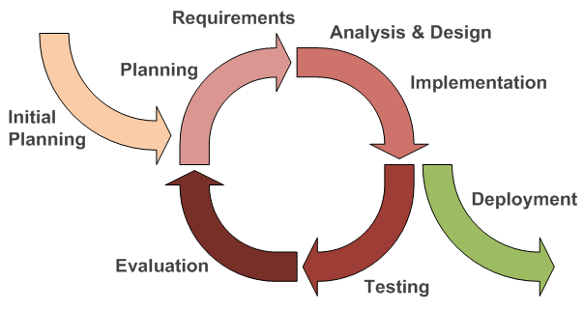development model helps to reach project goals in the most efficient way.

**Figure 3.1. Iterative and Incremental Development**

This figure showed the process in developing systems based on the producing deliverables through an iterative and incremental development cycle.

**3.1Initial Planning**

In this phase, we interviewed fellow Working students from the Audio Visual Center Office, faculty members of the Department of Computer Science, Director of Libraries, Head of Audio Visual Center, librarians and the technician of the Audio Visual Center at University of San Carlos Talamban Campus about our proposed system. After identifying the process of what should be done, we determined the system requirements as what our respondents and adviser recommended and identified the problems encountered while using the manual reservation of Audio Visual Rooms and Asset management system.

**3.2 Define Requirements**

In this phase, we defined the requirements by gathering data needed through more interviews, and schedule to gather more information in this study.

We defined that our client needs a reservation and asset management system in order for there to be more efficient and effective.

**3.3 Analysis and Design**

In this phase, we analyzed all the information gathered with the documentation of the project, interviews, and all needed data and came up with the solution to the problem.We established the kind of system that should be developed for the future University of San Carlos Audio Visual Center Asset Management and Reservation System after studying the University’s manual business process flow.

We also started creating lay-out, design, module, and prototype that will be needed for the efficiency of our proposedAudio Visual Center Asset Management and Reservation System. We created Flow Chart, ERD (Entity-Relation Diagram), Use Case Diagram to fully understand the flow of the University of San Carlos’ manual process into our proposed system.

**3.4 Implementation**

In this phase, we had already noted the requirements required by our respondents and adviser for the improvement of our Audio Visual Center Asset Management and Reservation system. Wefind out that there are problems encountered during the process of the system. Functions were also added to meet the requirements of the system.

**3.5 Testing and Evaluation**

In this phase, we are ready for testing our proposedAudio Visual Center Asset Management and Reservation system. We gathered all the testing results to identify from the different users of the system and were able to identify if there are any problems found in the proposed system. Evaluation from the users was made after testing the system in line with the system requirements.

**3.6 Deployment**

In this phase, we and the client will settle on if the system is ready for deployment or the system will undergo revisions for improvements. If the system is ready for deployment, we will present a user manual and conduct training on how to use our proposed system.

**CHAPTER 4**

**University of San Carlos Audio Visual Reservation and Asset Management System’s**

**Software Development**

**4.1 Requirement Specification**

This Section will describe the business flow, different interfaces, assumption and dependencies, constraint and the specific requirement of the project

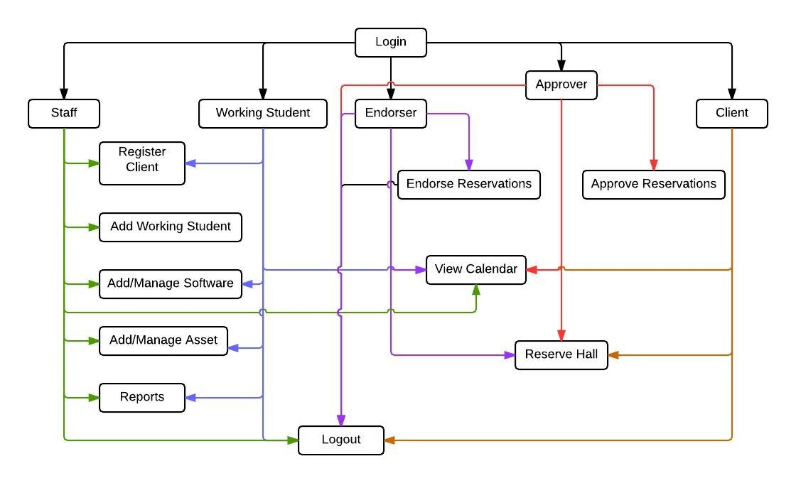 **4.1.1 Business Process Flow**

***Figure 4.1.1.1 Business Process Flow***

**4.1.2. System Interfaces**

As the developers gathered date and have seen in the business flow of the audio visual center, there are parts that can be automated.

The modules for our system are:

Login

* This module where the clients, approver, endorser, working student, and staff will input each username and password according their accounts.

Software Item

* This module has the record of each software materials found in the Audio Visual Office. It can add software materials and update the information of the materials. It can change the status of the materials if it is available or borrowed.

Asset Item

* This module has the record of assets found in the Audio Visual Office. It can add update the information of the assets.

Working Student

* This module has the record of working student found in a specific Audio Visual Office in the campus. It can add update the information of the working student.

Calendar

* This module displayed the reserved time and dates of all the halls in the university. It can be viewed weekly and monthly

Register

* This module registered different clients in the system. Client in the system can be a faculty, student or employee. The staff and working has the power to register these users.

Reservation

* This module reserved clients preferred time and date in using a hall.

Statistical Report

* This module generates the statistical data of the usage of the hall.

Endorser

* This module views the reservation form that need to be endorsed. This is where the reservation appears after submitting the form

Approver

* This module views the reservation form that need to be approved. This is where the reservation appears after it is being endorsed.

**4.1.3 User Interfaces**

The system provides login module where the staff, working student, approver, endorser, clients input their specific username and password. The staffs, working students, approvers, endorsers, clients have different module when they logged in. The staff can access all the modules except reservation, working student can also access some modules except reservation and working student, endorser can only access the reservation, calendar and endorser module, approver can only access the reservation, calendar and approver module, clients can only access the reservation and calendar module.

**4.1.4 Hardware Interfaces**

This section covers the different hardware we have used in order for the system to work.

**Table 4.1.4.1 Hardware Interfaces**

|  |  |
| --- | --- |
| Name | Purpose |
| **Desktop Computer/ Laptop** | To access the different modules in the system |
| **Internet Connection** | In order for the system to work online |
| **Printer** | To print the statistics that is needed by the staff. |

**44.1.5 Software Interfaces**

This section covers the different software we have used so far for this system and additional plug-ins that allowed it to work.

**Table 4.1.5.1 Software Interfaces**

|  |  |  |
| --- | --- | --- |
| Name | Version No. | Purpose |
| **Xampp** | **V3.2.1** | Interprets the scripts written in PHP and includes the SQL Database manipulation and uploading through Filezilla |
| **PHP** | **PHP 5.6.0** | All-purpose programming |
| **Bootstrap** | **V3.2.0** | To apply simple design and interior security checks(e.g. Pattern) |
| **Google Chrome** | **Version 37.0.2062.120** | For research purposes and used to adjust display for our website. |
| **Code Igniter** | **V2.2.0** | Used this PHP framework for efficient coding. |

**4.1.6 Communication Interfaces**

This project can be shown in the library system since the Audio Visual Center is under the library system and it can be access either outside or inside the university. The head and staff of each Audio Visual Center have an access with the system in order to manage the system. Another is the director of library system also needs to have an access so that he can view the reservation and statistics of the reservation system for some reasons. The director of the library system can’t edit and add software materials or assets. The director can only reserve a hall and reset the entire datum in the database

**4.1.7 User characteristics**

There arefive user rights for this system namely the Staff, Working Student, Approver, Endorser and the Client. The user side has all the rights of the system because he is the on managing it. The Working Student side has almost all the right except adding the working student. The approver can only approve reservations, view the availability and reserve hall. The endorser can only endorse reservations, view the availability and reserve hall. The client can only view the availability and reserve halls.

**4.1.8 Assumptions and dependencies**

In implementing the system, develops must know some of the assumptions and dependencies of the system to avoid problems in implementing it.

**Assumptions:**

* The clients should be faculty, student or employee in the University of San Carlos
* The users should have a sufficient knowledge of computers
* There must have an internet connection in accessing the system.

**Dependencies:**

* The different users will be able to input there correct username and password in using the different plug-ins of the system.

**4.1.10 Specific Requirements**

**4.1.10.1 Functional Requirements**

A. Login

**Table 4.1 Login**

|  |  |  |  |
| --- | --- | --- | --- |
| **Requirement No.** | **Description** | **Priority** | **Approved** |
| REQ 001 | The user shall be able to access the system using Chrome, Mozilla Firefox and Internet explorer | Required | Christian Maderazo |
| REQ 002 | Input username and password in order to log in | Required | Christian Maderazo |
| REQ 003 | The submit button is clickable | Required | Christian Maderazo |
| REQ 004 | Click the submit Log in button to validate the user’s log in | Required | Christian Maderazo |
| REQ 005 | The Forgot Password link is clickable | Required | Christian Maderazo |
| REQ 006 | When the user click the Forgot Password link, he will be redirected to another page | Required | Christian Maderazo |
| REQ 007 | The Want to register? link is clickable | Required | Christian Maderazo |
| REQ 008 | When the user clicks the Want to register? link, he will be redirected to another page | Required | Christian Maderazo |
| REQ 009 | The Log in box is located at the right side of the homepage | Required | Christian Maderazo |
| REQ 010 | The system description is located at the left side of the homepage | Required | Christian Maderazo |

**Table 4.2 Manage Hall**

|  |  |  |  |
| --- | --- | --- | --- |
| **Requirement No.** | **Description** | **Priority** | **Approved/** |
| REQ 001 | List of halls are displayed in tabular form | Requires | Christian Maderazo |
| REQ 002 | First column is the Campus name where the hall is located | Required | Christian Maderazo |
| REQ 003 | Second column is the name of the hall | Required | Christian Maderazo |
| REQ 004 | The third column is the number of capacity of the hall | Required | Christian Maderazo |
| REQ 005 | The fourth column is the description of the hall | Required | Christian Maderazo |
| REQ 006 | The update icon and the delete icon are located at the fifth column of the | Required | Christian Maderazo |
| REQ 007 | The update icon is clickable | Required | Christian Maderazo |
| REQ 008 | When the user click the update icon, a modal will appear | Required | Christian Maderazo |
| REQ 009 | In the update modal, the text fields are Campus name, Hall name, Capacity, and the Description and are displayed vertically. | Required | Christian Maderazo |
| REQ 010 | In the update modal, all text fields are required | Required | Christian Maderazo |
| REQ 011 | In the update modal, submit button is clickable | Required | Christian Maderazo |
| REQ 012 | In the update modal, when the user click the submit button, the modal will disappear and the inputs will be validated | Required | Christian Maderazo |
| REQ 013 | If the inputs from the updates is successfully validated, the table will be updated else the error will appear | Required | Christian Maderazo |
| REQ 014 | The delete button is clickable | Required | Christian Maderazo |
| REQ 015 | When the user clicks the delete button, the row will be deleted. | Required | Christian Maderazo |
| REQ 016 | The add icon located below the table. | Required | Christian Maderazo |
| REQ 017 | When the user click the add icon, a modal will appear. | Required | Christian Maderazo |
| REQ 018 | In the add modal, all text fields are required | Required | Christian Maderazo |
| REQ 019 | In the add modal, submit button is clickable | Required | Christian Maderazo |
| REQ 020 | In the add modal, when the user click the submit button, the modal will disappear and the inputs will be validated | Required | Christian Maderazo |
| REQ 021 | If the inputs from the updates is successfully validated, the table will be updated else the error will appear | Required | Christian Maderazo |

**Table 4.3 Manage Software**

|  |  |  |  |
| --- | --- | --- | --- |
| **Requirement No.** | **Description** | **Priority** | **Approved/** |
| REQ 001 | List of all software are displayed in tabular form | Requires | Christian Maderazo |
| REQ 002 | First column is the call numberof the software | Required | Christian Maderazo |
| REQ 003 | Second column is the title name of the software | Required | Christian Maderazo |
| REQ 004 | The third column is the status of the software | Required | Christian Maderazo |
| REQ 005 | The fourth column is the name of the borrower of the software | Required | Christian Maderazo |
| REQ 006 | The update icon and the delete icon are located at the fifth column of the | Required | Christian Maderazo |
| REQ 007 | The update icon is clickable | Required | Christian Maderazo |
| REQ 008 | When the user click the update icon, a modal will appear | Required | Christian Maderazo |
| REQ 009 | In the update modal, the text fields are Call number, Title, status and are displayed vertically. | Required | Christian Maderazo |
| REQ 010 | In the update modal, all text fields are required | Required | Christian Maderazo |
| REQ 011 | In the update modal, submit button is clickable | Required | Christian Maderazo |
| REQ 012 | In the update modal, when the user click the submit button, the modal will disappear and the inputs will be validated | Required | Christian Maderazo |
| REQ 013 | If the inputs from the updates is successfully validated, the table will be updated else the error will appear | Required | Christian Maderazo |
| REQ 014 | The delete button is clickable | Required | Christian Maderazo |
| REQ 015 | When the user clicks the delete button, the row will be deleted. | Required | Christian Maderazo |
| REQ 016 | The add icon located below the table. | Required | Christian Maderazo |
| REQ 017 | When the user click the add icon, a modal will appear. | Required | Christian Maderazo |
| REQ 018 | In the add modal, all text fields are required | Required | Christian Maderazo |
| REQ 019 | In the add modal, submit button is clickable | Required | Christian Maderazo |
| REQ 020 | In the add modal, when the user click the submit button, the modal will disappear and the inputs will be validated | Required | Christian Maderazo |
| REQ 021 | If the inputs from the updates is successfully validated, the table will be updated else the error will appear | Required | Christian Maderazo |

**Table 4.4 Manage Assets**

|  |  |  |  |
| --- | --- | --- | --- |
| **Requirement No.** | **Description** | **Priority** | **Approved/** |
| REQ 001 | List of all assets are displayed in tabular form | Requires | Christian Maderazo |
| REQ 002 | First column is the quantity number of the equipment | Required | Christian Maderazo |
| REQ 003 | Second column is the name of the equipment | Required | Christian Maderazo |
| REQ 004 | The third column is the serial number of the equipment | Required | Christian Maderazo |
| REQ 005 | The fourth column is the name of the status of the equipment | Required | Christian Maderazo |
| REQ 006 | The update icon and the delete icon are located at the fifth column of the | Required | Christian Maderazo |
| REQ 007 | The update icon is clickable | Required | Christian Maderazo |
| REQ 008 | When the user click the update icon, a modal will appear | Required | Christian Maderazo |
| REQ 009 | In the update modal, the text fields are Quantity, name, serial number, and status and are displayed vertically. | Required | Christian Maderazo |
| REQ 010 | In the update modal, all text fields are required | Required | Christian Maderazo |
| REQ 011 | In the update modal, submit button is clickable | Required | Christian Maderazo |
| REQ 012 | In the update modal, when the user click the submit button, the modal will disappear and the inputs will be validated | Required | Christian Maderazo |
| REQ 013 | If the inputs from the updates is successfully validated, the table will be updated else the error will appear | Required | Christian Maderazo |
| REQ 014 | The delete button is clickable | Required | Christian Maderazo |
| REQ 015 | When the user clicks the delete button, the row will be deleted. | Required | Christian Maderazo |
| REQ 016 | The add icon located below the table. | Required | Christian Maderazo |
| REQ 017 | When the user click the add icon, a modal will appear. | Required | Christian Maderazo |
| REQ 018 | In the add modal, all text fields are required | Required | Christian Maderazo |
| REQ 019 | In the add modal, submit button is clickable | Required | Christian Maderazo |
| REQ 020 | In the add modal, when the user click the submit button, the modal will disappear and the inputs will be validated | Required | Christian Maderazo |
| REQ 021 | If the inputs from the updates is successfully validated, the table will be updated else the error will appear | Required | Christian Maderazo |

**Table 4.5 Manage User**

|  |  |  |  |
| --- | --- | --- | --- |
| **Requirement No.** | **Description** | **Priority** | **Approved/** |
| REQ 001 | List of all users are displayed in tabular form | Requires | Christian Maderazo |
| REQ 002 | First column is the Family Name of the user | Required | Christian Maderazo |
| REQ 003 | Second column is the Last name of the user | Required | Christian Maderazo |
| REQ 004 | The third column is the username of the user | Required | Christian Maderazo |
| REQ 005 | The fourth column is the type of the user | Required | Christian Maderazo |
| REQ 006 | The delete icon located at the fifth column of the | Required | Christian Maderazo |
| REQ 007 | The delete button is clickable | Required | Christian Maderazo |
| REQ 008 | When the user clicks the delete button, the row will be deleted. | Required | Christian Maderazo |
| REQ 009 | The Update Password is located at the sixth column | Required | Christian Maderazo |
| REQ 010 | The Update Password is clickable | Required | Christian Maderazo |
| REQ 011 | When the user clicks the update password, it will be redirected to the updatePassword.php | Required | Christian Maderazo |
| REQ 012 | If the updated password is success the success modal will appear else the failed modal will appear | Required | Christian Maderazo |
| REQ 013 | The add icon is located at the right above the table and is clickable | Required | Christian Maderazo |
| REQ 014 | When the staff/working student click the add icon, it redirects to the Register page | Required | Christian Maderazo |
| REQ 015 | If the staff/working student misses one or more fields to fill up an error will appear | Required | Christian Maderazo |
| REQ 016 | The Register button is located at the bottom of the form and is clickable | Required | Christian Maderazo |
| REQ 017 | When the user clicks the Register button, the form will be validated | Required | Christian Maderazo |
| REQ 018 | If the validation is success the user will be redirected to the list of users else an error will appear. | Required | Christian Maderazo |

**Table 4.6 Change password**

|  |  |  |  |
| --- | --- | --- | --- |
| **Requirement No.** | **Description** | **Priority** | **Approved** |
| REQ 001 | There are 3 text fields: Current password, New Password and Re-type password | Required | Christian Maderazo |
| REQ 002 | The submit button is clickable. | Required | Christian Maderazo |
| REQ 003 | When the user click the submit button, the inputs will be validated | Required | Christian Maderazo |
| REQ 004 | If the validation is successful the success message will appear above the Current Password | Required | Christian Maderazo |

**Table 4.7Reservation**

|  |  |  |  |
| --- | --- | --- | --- |
| **Requirement No.** | **Description** | **Priority** | **Approved/** |
| REQ 001 | Clicking from Reservation from the navigation bar, the reservation page will appear | Requires | Christian Maderazo |
| REQ 002 | Dropdown campus will be displayed below the title page. | Required | Christian Maderazo |
| REQ 003 | Dropdown hall names will be displayed below the campus dropdown. | Required | Christian Maderazo |
| REQ 004 | Date field is displayed below the hall names | Required | Christian Maderazo |
| REQ 005 | Date field is using a date picker | Required | Christian Maderazo |
| REQ 006 | Time start and time end dropdowns are displayed horizontally below the date picker. | Required | Christian Maderazo |
| REQ 007 | The validate button is clickable. | Required | Christian Maderazo |
| REQ 008 | When the user click the validate button, a modal will appear. | Required | Christian Maderazo |
| REQ 009 | If the validation is success the reservation form will appear else the failed modal will appear | Required | Christian Maderazo |
| REQ 010 | The reservation form contains all the details that the user needs to fill. | Required | Christian Maderazo |
| REQ 011 | All text fields in the reservation form are required. | Required | Christian Maderazo |
| REQ 012 | The submit button is located below the reservation form. | Required | Christian Maderazo |
| REQ 013 | The submit button is clickable. | Required | Christian Maderazo |
| REQ 014 | When the user click the submit button, the form will be validated. | Required | Christian Maderazo |
| REQ 015 | If the form is successfully validated, the user will be redirected to the success page else the error will be displayed at the top of the reservation form. | Required | Christian Maderazo |

**4.2. Design Specification**

**4.2.1 Component Diagram (a UML diagram)**

***Figure 4.2.1 Component Diagram***

**4.2.2 High-level Use Case (a UML diagram)**

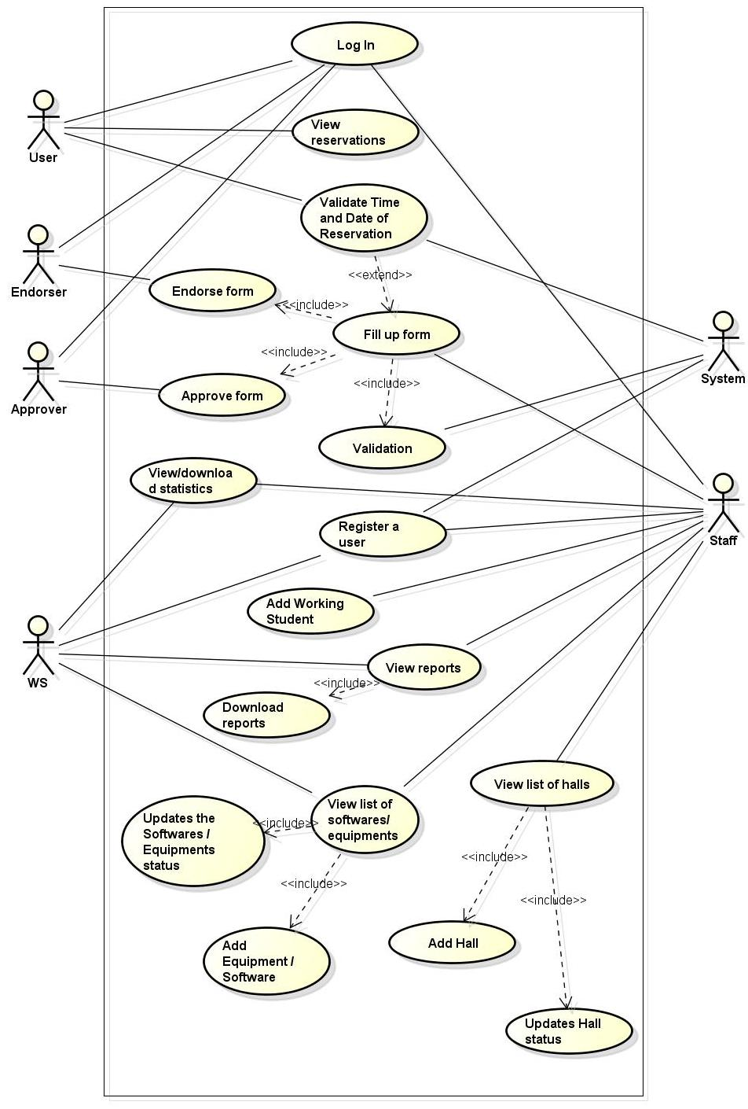

***Figure 4.2.2 High-level Use Case Diagram***

**4.2.3 Entity Relationship Diagram**

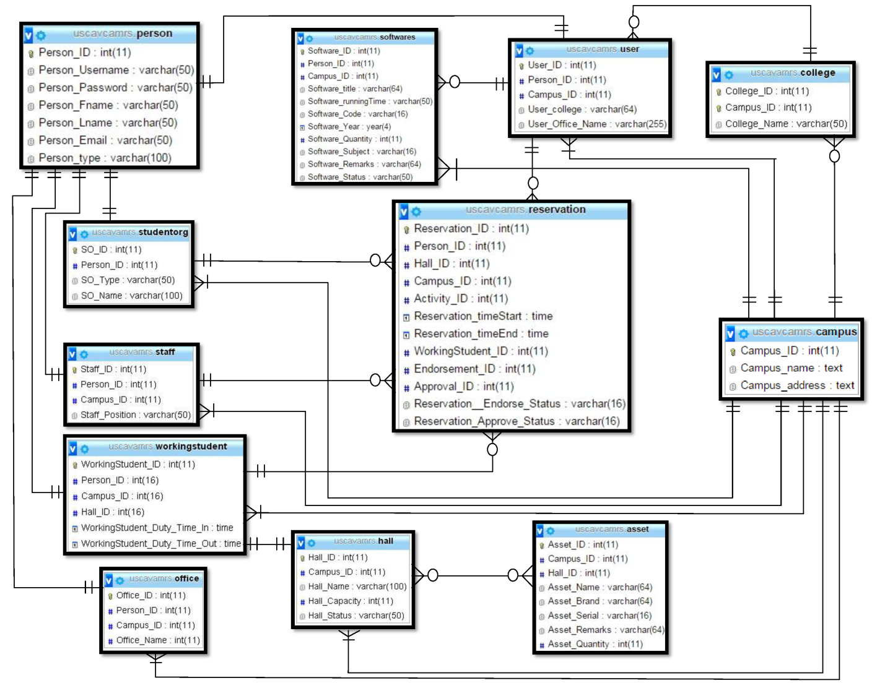

***Figure 4.2.3 Entity Relationship Diagram***

**4.3 Testing and Evaluation**

**Table 4.8Log in**

|  |  |  |  |  |
| --- | --- | --- | --- | --- |
| **User** | **Input** | **Expected result** | **Actual Result** | **Status** |
| 1.Empty fields | *blank fields | Please fill out the fields |  |  |
| 2. Input Username | Username | Log in success |  |  |
| Username | Invalid username or password |  |  |
| 3. Input password | Password | Log in success |  |  |
| Password | Invalid username or password |  |  |
| 1.Empty fields | *blank fields | Please fill out the fields |  |  |

**Table 4.9 Manage Hall**

|  |  |  |  |  |
| --- | --- | --- | --- | --- |
| **User** | **Input** | **Expected result** | **Actual Result** | **Status** |
| 1.Empty fields | *blank fields | Please fill out the (name of field) field |  |  |
| 2. Hall name | Hall name | Success |  |  |
| 3. Capacity | Integer | Success |  |  |
| Float or Character | Capacity number is invalid |  |  |
| 4. Description | Description | Success |  |  |
| Description | Must be 100 characters |  |  |

**Table 4.10 Manage Software**

|  |  |  |  |  |
| --- | --- | --- | --- | --- |
| **User** | **Input** | **Expected result** | **Actual Result** | **Status** |
| 1.Empty fields | *blank fields | Please fill out the (name of field) field |  |  |
| 2. Call number | Call number | Success |  |  |
| Call number (Number only) | Must have a character |  |  |
| Call number (Characters only) | Must have a number |  |  |
| 3. Software name | Text | Success |  |  |

**Table 4.11 Manage Assets**

|  |  |  |  |  |
| --- | --- | --- | --- | --- |
| **User** | **Input** | **Expected result** | **Actual Result** | **Status** |
| 1.Empty fields | *blank fields | Please fill out the (name of field) field |  |  |
| 2. Quantity | Integer | Success |  |  |
| Float | Must be a whole number |  |  |
| Character | Must be a whole number |  |  |
| 3. Asset Name | Text | Success |  |  |
|  | Text (below 4 characters) | Must be 4 or more characters |  |  |
| 4. Serial number | Text | Success |  |  |
| Text (below 3 characters) | Must be 3 or more characters |  |  |

**Table 4.12 Manage User**

|  |  |  |  |  |
| --- | --- | --- | --- | --- |
| **User** | **Input** | **Expected result** | **Actual Result** | **Status** |
| 1.Empty fields | *blank fields | Please fill out the (name of field) field |  |  |
| 2. First Name | Text | Success |  |  |
| Text (below 2 characters) | Must be 2 characters or more |  |  |
| 3. Last Name | Text | Success |  |  |
| Text (below 2 characters) | Must be 2 characters or more |  |  |
| 4. Username | Text | Success |  |  |
| Text (below 6 characters) | Must be 6 characters or more |  |  |
| 5. Email | Email (valid email) | Success |  |  |
| Email (not valid email) | Email is incorrect |  |  |

**Table 4.13 Change Password**

|  |  |  |  |  |
| --- | --- | --- | --- | --- |
| **User** | **Input** | **Expected result** | **Actual Result** | **Status** |
| 1.Empty fields | *blank fields | Please fill out the (name of field) field |  |  |
| 2. Current Password | Text | Success |  |  |
| Text (below 6 characters) | Must be 6 characters or more |  |  |
| Text (incorrect password) | Incorrect Password |  |  |
| 3. New Password | Text | Success |  |  |
| Text (below 6 characters) | Must be 6 characters or more |  |  |
| 4. Re-type Password | Text | Success |  |  |
|  | Text | Password didn’t match |  |  |

**Table 4.14 Reservation**

|  |  |  |  |  |
| --- | --- | --- | --- | --- |
| **User** | **Input** | **Expected result** | **Actual Result** | **Status** |
| 1.Empty fields | *blank fields | Please fill out the (name of field) field |  |  |
| 2. Others” | Text | Success |  |  |
| Text (below 10 character) | Must be 10 or more characters |  |  |
| 3. Client Software | Text | Success |  |  |

**CHAPTER V**

**INTRODUCTION**

This chapter is made to analyze and interpret the data we have worked to acquire regarding the company’s system evaluation. The persons involved in the system were also included in the evaluation. The developers used an evaluation form as an instrument in gathering data in order to determine the approval rate of the company and measure the quality of the system.

# CHAPTER VI

**CONCLUSION AND RECOMMENDATIONS**

This chapter presents or discusses the developers’ conclusions that are based on the objectives stated in Chapter I. The recommendations for the improvement of the system are also included in this chapter.